CSCI251 Assignment 2 Report
Ayken Lee Kang 1035289

Overview and Requirements of the Program
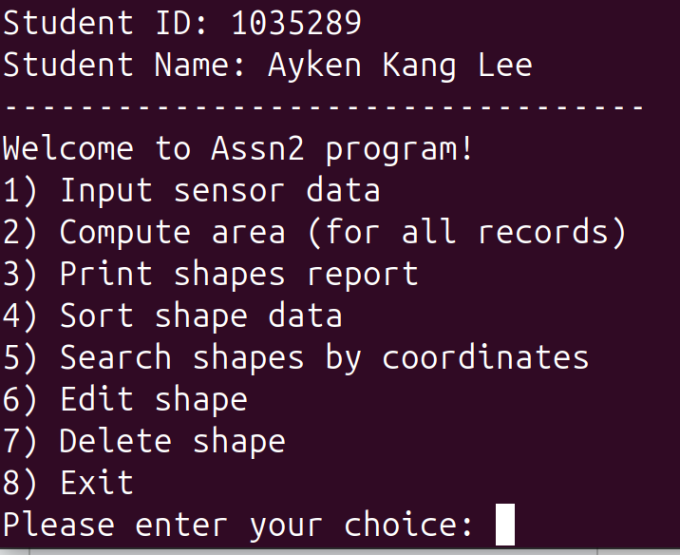
The 2D shape analysis program I designed is able to execute all basic functions listed in the assignment requirements, along with a few additional features. The program processes sensor data for different 2D shapes (Square, Rectangle, Cross, and Circle), computes their areas, checks point inclusion, and generates reports. The implementation uses object-oriented programming principles, including encapsulation, inheritance, polymorphism, and function overloading in C++. Additional features include coordinate searching to check occupancy of points, and an edit and delete shape feature for users to make amendments to their inputs.

Class Diagram
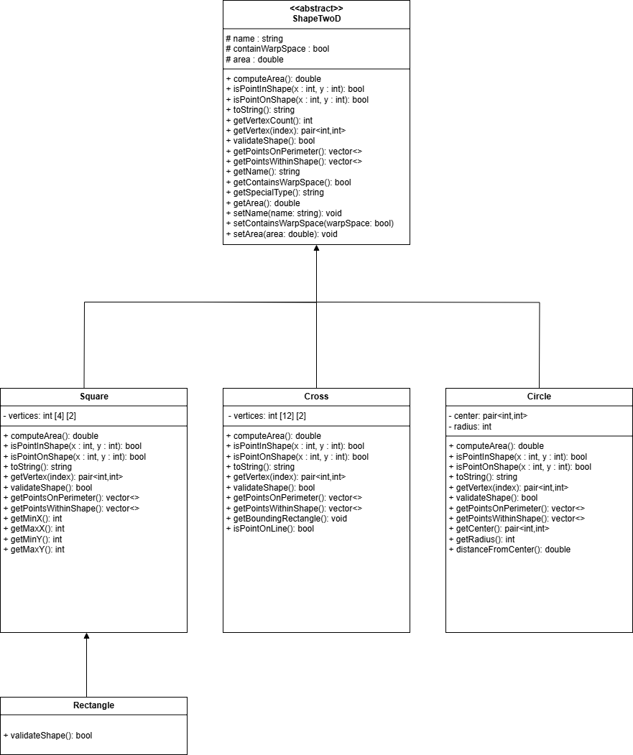

Summary of Implementations

ShapeTwoD
Implementing ShapeTwoD correctly is vital as it serves as the abstract base class for all 2D shapes in the program, which enforces a consistent logic and flow throughout the program with the use of polymorphism and encapsulation. It contains important virtual methods, such as computeArea(), isPointInShape(), and isPointOnShape(), for the derived classes to implement. This will ensure uniform behaviour across all the shape classes. The classes store common attributes like name, cotainsWarpSpace, and area, with some using protected access to enforce encapsulation while allowing derived classes to carry out its functions. Another important step was including pure virtual methods such as validateShape() to allow shapes to implement validation, which will guarantee its accuracy in calculation. This design also uses dynamic binding, which allows the main program to interact with shapes generically while leveraging each subclass’s specific implementations for area calculation, point containment checks and reporting. This base class structure is designed to ensure scalability, making it flexible in adding new shape types without modifying the main bulk of the program.

Square
The Square class, derived from ShapeTwoD, implements a 2D square defined by four vertices. It enforces strict geometric validation to ensure all sides are equal and angles are 90 degrees using Euclidean distance and dot product checks. The computeArea() method calculates the area as sideLength squared, while getPointsOnPerimeter() and getPointsWithinShape() generate points along the edges and inside the square, respectively. Input validation rejects non-integer coordinates and invalid shapes when the user finishes inputting the 4 coordinates.

Rectangle
The Rectangle class inherits from Square but modifies validation to allow adjacent sides of unequal length while ensuring opposite sides remain equal and parallel. It reuses Square’s methods for area calculation of sideLength * sideLength and point generation but overrides validateShape() to verify rectangle-specific properties. This design avoids redundancy while maintaining accurate geometric constraints.

Cross
The Cross class implements a plus-shaped 2D object by calculating its area using an efficient bounding-box subtraction method. First, the algorithm determines the smallest enclosing rectangle that completely contains the cross shape. Then, it identifies and computes the combined area of the four rectangular corners that lie outside the actual cross structure. The final cross area is derived by subtracting these four corner areas from the total bounding rectangle area. This approach provides an accurate and mathematically sound calculation while maintaining computational efficiency. The class also includes robust validation to ensure the 12 input vertices form a proper cross shape with correctly aligned horizontal and vertical arms. For point containment checks, the implementation uses precise geometric tests to determine whether coordinates lie on the cross's perimeter or within its bounds, ensuring reliable results for both regular and irregular cross configurations. This bounding-box subtraction method offers a clear geometric interpretation of the cross's area while simplifying the calculation process compared to alternative approaches.

Circle
The Circle class simplifies input to a center point and radius. It calculates area and checks point inclusion using distance comparisons. Unlike polygons, it outputs only four cardinal perimeter points, North, South, East, and West, as specified. Input validation ensures that users enter positive radius, and decimal coordinates are rejected to maintain precision.

Assn2.cpp
This file is designed to be the central driver for the program, integrating a menu for users to navigate and use the program. Users can input, process, and review the shapes through polymorphic interactions with the ShapeTwoD class hierarchy. The program begins by displaying a main menu with options to input sensor data for various shapes, such as Square, Rectangle, Cross, and Circle, where each input undergoes strict validation to ensure integer-only coordinates and proper shapes are formed. Once shapes are stored, the program can compute their areas through dynamic polymorphism, with each shape type using its specific area calculation logic while maintaining a consistent interface. Users can generate detailed reports which display vertices, perimeter points, and interior points, with special handling for circles to display only the four cardinal perimeter points. Additionally, the program provides sorting functionality, allowing shapes to be organized by area (ascending or descending) or by special type (prioritizing "WS" warp-space shapes) and area, demonstrating effective use of comparator functions and STL sorting algorithms. The implementation emphasizes clean code structure through modular functions for input handling, validation, and output formatting, while robust error handling prevents crashes from invalid user input. Memory management is carefully handled through explicit cleanup of shape objects, and the console interface provides clear feedback at each step, making the program both user-friendly and technically sound for processing 2D geometric data as specified in the assignment requirements.

Testing

Test Cases
The program was tested in detail to ensure that all functionalities could perform correctly and robustly. Unit tests were conducted for each shape to verify accurate area calculations and correct perimeters. This would be vital for accurate displaying of reports and sort function. Integrated testing confirmed that polymorphic behaviors worked as intended, with the main menu correctly processing mixed shape types through the ShapeTwoD interface. Sorting functionality was verified by checking outputs against manually computed expected orders, while memory leaks were monitored to ensure proper cleanup of dynamically allocated shapes. The testing process combined manual verification with targeted test cases, ensuring the program meets all assignment requirements while handling real-world usage scenarios reliably.

Edge Cases
Edge cases, such as shapes with minimal dimensions or points exactly on edges, were validated to confirm geometric precision. The input system was tested with invalid data (decimal coordinates, non-numeric entries, and incorrect shape configurations) to ensure proper error handling and user feedback.

Additional features

The program has been enhanced with two key features: coordinate searching, and shape editing and deletion, significantly improving its functionality and user experience. Users have the option to search for coordinates, to understand whether there is a shape at said point. This can be a stepping stone in implementing a pathfinding feature for the program. The edit feature allows users to modify a shape's name, special type, or geometric properties, such as vertices for squares/rectangles, radius for circles, with all changes validated to ensure data integrity. The delete feature enables safe removal of shapes, complete with a confirmation prompt to prevent accidental data loss. Both features integrate seamlessly with the existing codebase, maintaining robust memory management and automatic area recomputation.
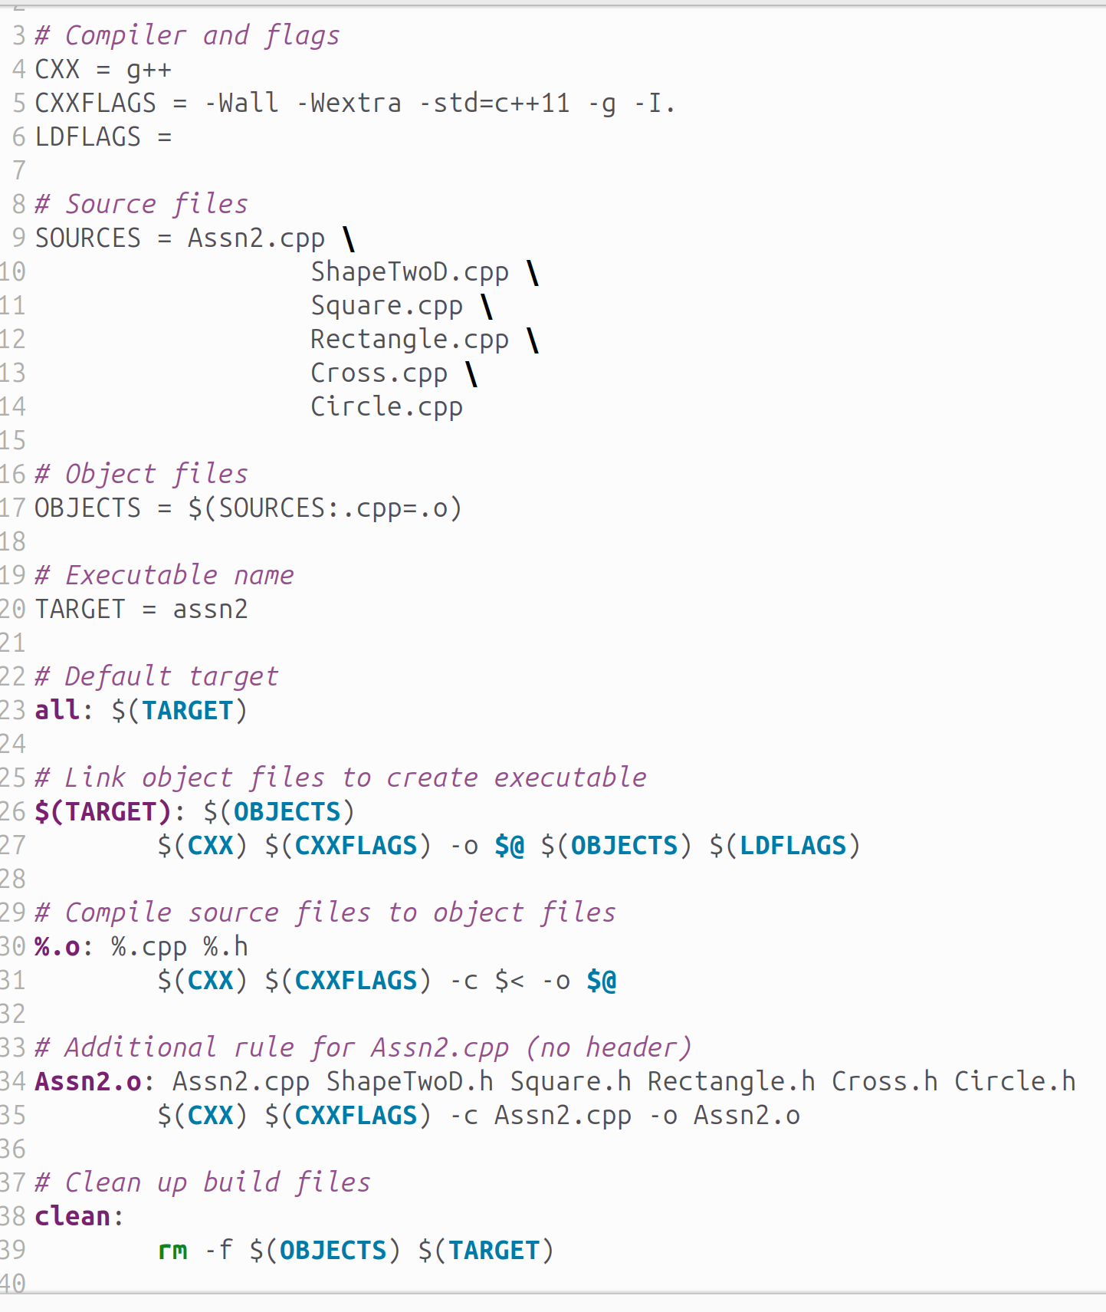
Additionally, I created a Makefile to make compiling and running the code more convenient. This is espeicially useful in a bigger assignment such as this assignment 2, where there are many .o and .h files that need to be compiled together to run the program.

Reflections on Program Development

Challenges Faced
Several key challenges were encountered during the development of this 2D shape analysis program. One major difficulty was ensuring accurate geometric validation, particularly for the Cross class, where verifying the proper positioning of 12 vertices required careful mathematical checks for intersecting lines and arm widths. The area calculation logic for complex shapes like crosses initially produced incorrect results until I implemented the bounding-box subtraction method.
Another challenge was handling polymorphic behavior consistently across all shape classes while maintaining precise coordinate checks for point containment and perimeter detection. Input validation proved particularly tricky when rejecting decimal numbers while still accepting negative coordinates, requiring robust string parsing. Memory management issues surfaced during early testing, with occasional leaks from improperly handled shape objects, which was resolved by implementing explicit cleanup in the destructor. The sorting functionality initially struggled with maintaining stable ordering when multiple shapes had identical areas, requiring additional tie-breaker logic. For the Circle class, reconciling the assignment's requirement for only four perimeter points with mathematical precision demanded careful rounding strategy implementation. These challenges were systematically addressed through iterative testing, mathematical verification of geometric properties, and careful refactoring of the class hierarchy, ultimately resulting in a robust and accurate implementation that meets all specified requirements.

Assumptions Made
Several key assumptions include all shapes being axis-aligned (as mentioned in the brief), with edges strictly parallel to the x and y coordinate axes. Input coordinates are restricted to integer values only, rejecting decimal inputs to avoid floating-point precision complexities in point-in-shape checks. For crosses, the 12-vertex structure is presumed to form a symmetrical plus-sign with uniform arm thickness, though the validation does permit some irregularity in arm dimensions. The circle's perimeter output assumes only cardinal direction points need reporting, omitting intermediate perimeter points for simplicity. Memory constraints are mitigated by capping shape storage at 100 objects, ensuring that crashes in the system are kept to a minimum. These deliberate simplifications enabled focused development on core polymorphic behaviors while clearly defining the program's operational boundaries. Testing confirmed these assumptions hold for the specified use cases while highlighting potential limitations for future expansion.

Lessons Learnt
This project has taught me several key programming principles. First, it showcased the power of polymorphism when creating clean, extensible code. By designing an efficient abstract base class, ShapeTwoD, with virtual functions, adding new shapes became straightforward while ensuring consistent behavior. Secondly, input validation proved vital, by rejecting invalid data early, like decimals or malformed shapes, to prevent subtle bugs and errors in geometric calculations. The challenges in calculating areas especially for complex shapes like crosses taught the importance of algorithmic precision and multiple verification methods. Memory management lessons surfaced when forgetting to delete dynamically allocated shapes caused leaks, which introduces the opportunity for smart pointers in future projects. The sorting functionality highlighted how comparator design affects usability, while testing revealed edge cases that initially worked against the program’s logic. Finally, the project demonstrated how assumptions like axis alignment must be clearly documented to define system boundaries. These takeaways will inform more maintainable and robust designs in future work.

Future Enhancements
Several improvements could help improve the program’s functionality and robustness. First, taking the idea from assignment to use of file I/O would allow users to save and load shape configurations, enabling persistent data storage and processing. Second, adding GUI visualization would provide intuitive visual feedback for shape placement and path planning. Support for rotated shapes could be introduced by extending the geometry calculations to handle various orientations, broadening the program’s applicability. Third, integrating a pathfinding algorithm , such as A* or Dijkstra’s, would automate navigation through shapes, aligning with the assignment’s "2D-StarFleet" theme. Error handling could be refined with custom exceptions for clearer debugging, while unit testing frameworks like Google Test would ensure reliability as features expand. Finally, removing the 100-shape limit and optimizing data structures would enhance scalability for larger datasets. These enhancements would transform the project from an assignment into a more versatile and practical tool for geometric analysis.

